SE4041 – Mobile Application Design and Development
Assignment 01 – UI Prototype Submission
Community Services and Local Marketplace Mobile Application

Brand wordmark: යාළුway | Help nearby. Trade nearby. Trust nearby.

Faculty of Computing
BSc (Hons) in Information Technology | Year 4 – Semester 1 & 2
Sandaruwan W J – IT22294548
Figma prototype: https://www.figma.com/design/0UVq1JYisRj6rl7UoadYFi/Untitled

1. Introduction
This document submits the Figma UI prototype for යාළුway (Yaluway), designed under the assigned domain Community Services and Local Marketplace. The prototype covers ideation, the 60-30-10 colour rule, main interface design, and aesthetics and usability, matching the SE4041 marking scheme.
යාළුway is a hyperlocal neighbourhood notice-board app. People nearby can post three kinds of things in one place: community Help, local Services, and Marketplace goods (sell, donate, or borrow). The UI is designed as one listing app with three post types, not three separate products.

1.1 Purpose of this submission
- Present the complete Figma prototype screens with labelled explanations.
- Show how ideation is translated into interface structure and visual identity.
- Demonstrate consistent 60-30-10 colour application across all screens.
- Explain usability choices that support the later Kotlin / Room implementation.

1.2 Prototype overview
The prototype contains 15 mobile frames (iPhone 14 / 390 × 844) plus a Design system page. Screens are linked in Figma Prototype so the flow can be clicked from Splash to Profile.
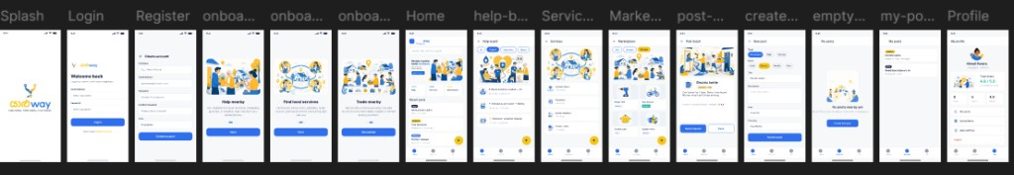
Figure 1. Complete Figma UI prototype (all screens on one canvas).

2. Ideation
Ideation marks assess whether the idea is innovative, fits the assigned domain, and clearly addresses user needs. The UI is the visual proof of that idea.

2.1 Problem the interface solves
In Sri Lanka, neighbourhood help and local trade still happen on WhatsApp groups and Facebook Marketplace. Those channels are noisy, hard to search, weak on trust, and not designed for both community service and local commerce together. යාළුway’s interface puts Help, Services, and Marketplace in one structured mobile path.

2.2 Brand meaning used in the UI
Yalu (යාළු / friend) + Way (path) means a friendly local path to get help, offer services, and trade nearby. Tagline: Help nearby. Trade nearby. Trust nearby.
- Yellow in the wordmark stands for friendship and warmth (යාළු).
- Blue in the wordmark stands for trust and direction (way).
- Handshake / pin icon represents two neighbours meeting on a local path.

2.3 How ideation appears in the screens
UI decision | Why it supports the idea
Home chips: Help | Services | Marketplace | Shows the 3-in-1 model immediately.
Onboarding in three slides | Teaches the three modules before first use.
Borrow / Donate / Sell chips | Goes beyond classified ads; supports neighbour culture.
Area label (Nugegoda / Hostel A) | Hyperlocal, not island-wide anonymous listings.
Trust score on Profile | Neighbour trust is a core differentiator.
No payment or chat screens | MVP stays academic and buildable in Kotlin + Room.

2.4 Target users reflected in content
Screen copy uses Sri Lankan neighbourhood examples so the panel can see the audience: students (textbooks, kettle, maths tutor), residents (plumber, blood request), and home providers (baker, cleaner). Persona Nimali Perera appears on Profile and post-detail.

3. Application of the 60-30-10 Colour Rule
The 60-30-10 rule controls how much of the screen each colour occupies. It is not three colours mixed equally. 60% is the dominant canvas, 30% is the primary brand/action colour, and 10% is a small accent used for attention.

3.1 Colour palette
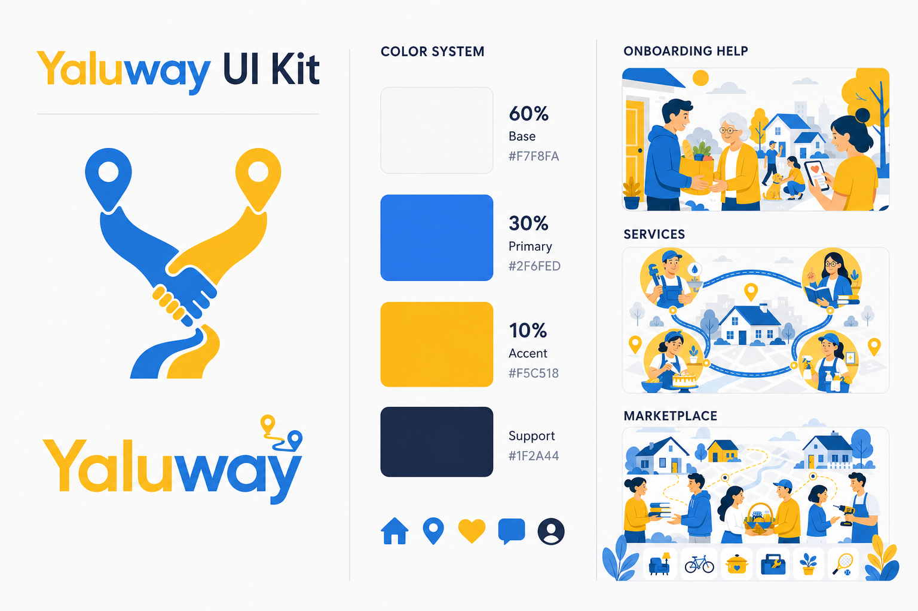
Figure 2. Design system / 60-30-10 palette used in the prototype.
Share | Role | Hex | Where it is used
60% | Background | #F7F8FA | Screen canvas on every frame
30% | Primary (Way blue) | #2F6FED | Buttons, selected chips, links, “way”
10% | Accent (Yalu yellow) | #F5C518 | FAB +, Borrow badge, යාළු wordmark
Support | Text navy | #1F2A44 | Headings and body text
Support | Card white | #FFFFFF | Cards, input fields
Support | Success teal | #2BBBAD | Success / available states

3.2 How the rule is applied on a typical screen
Example — Home:
- 60%: large off-white background around header, chips, and cards.
- 30%: selected chip, primary actions, and blue brand elements.
- 10%: yellow + FAB and yellow BORROW badge. Small area, high noticeability.
The same split is repeated on Login (blue Log in button, yellow Create account link), Marketplace (blue title/actions, yellow selected Borrow chip), and post-detail (blue Send request, yellow BORROW · FREE pill). Yellow is never used as a second background. If yellow covered half the screen, the 10% rule would break.

3.3 Consistency check
Colour styles named Yaluway/Background, Yaluway/Primary Blue, Yaluway/Accent Yellow, Yaluway/Text Navy, Yaluway/Success Teal, and Yaluway/Cards were created in Figma so every screen uses the same tokens.

4. Information Architecture and User Flow
Navigation is kept simple so the same pattern can be coded later with Activities / Fragments and a bottom bar.
Stage | Screens | User goal
Entry | Splash → Login / Register | Recognise brand and sign in
Learn | Onboarding Help → Services → Marketplace | Understand the 3 modules
Discover | Home, Help board, Services, Marketplace | Browse nearby posts
Act | Post detail, Create post | Request help or publish a listing
Manage | My posts, Empty state, Profile | See own activity and account

Prototype click path used for demonstration:
Splash → Login → Home. New user: Login Create account → Register → Onboarding Help → Onboarding Services → Onboarding Marketplace → Home. From Home: chips open Help / Services / Marketplace; a card opens Post detail; yellow + opens Create post; bottom nav opens My posts or Profile.

5. Main Interface Design
This section presents each screen with a screenshot and a short explanation of purpose, layout, and usability. Screens are grouped by user journey.

5.1 Splash, Login and Register
Splash introduces the brand without clutter. Login is the launcher for returning users. Register collects only what the MVP needs: name, email, password, confirm password, and area. Area (example: Nugegoda) is required because discovery is neighbourhood-first.
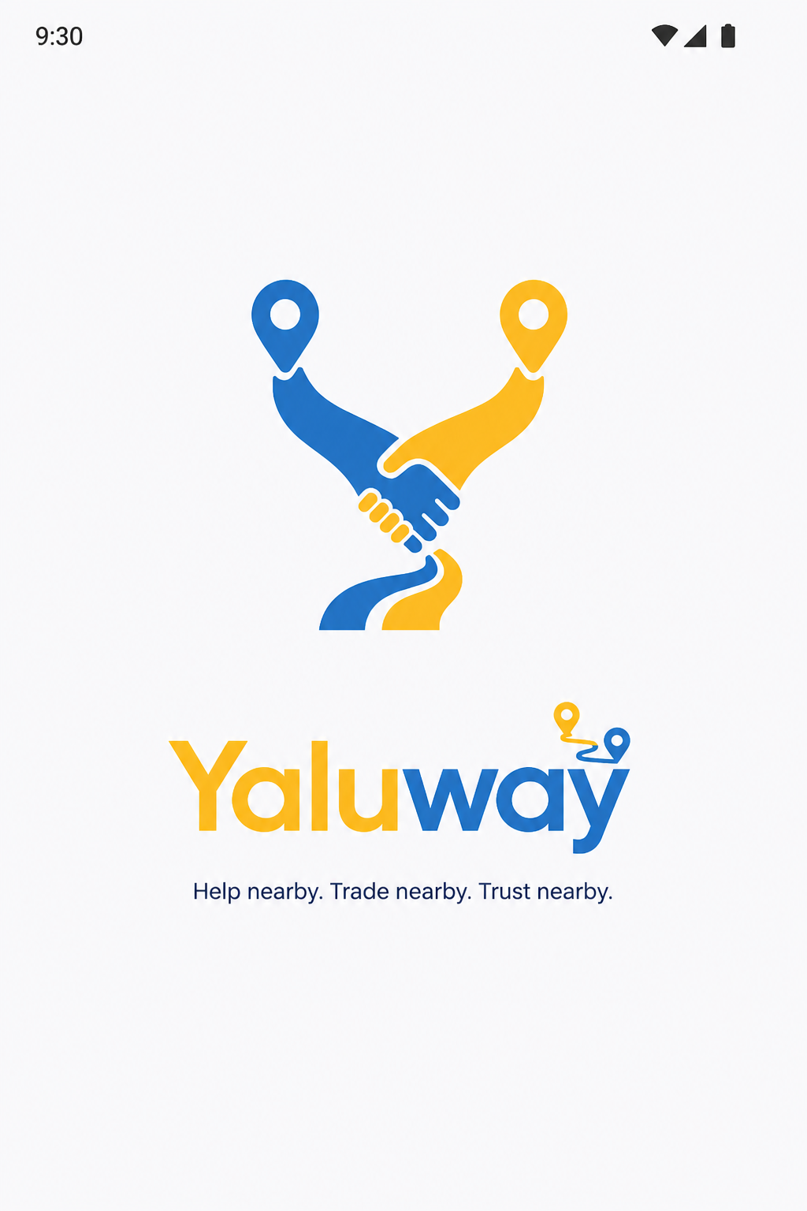 | 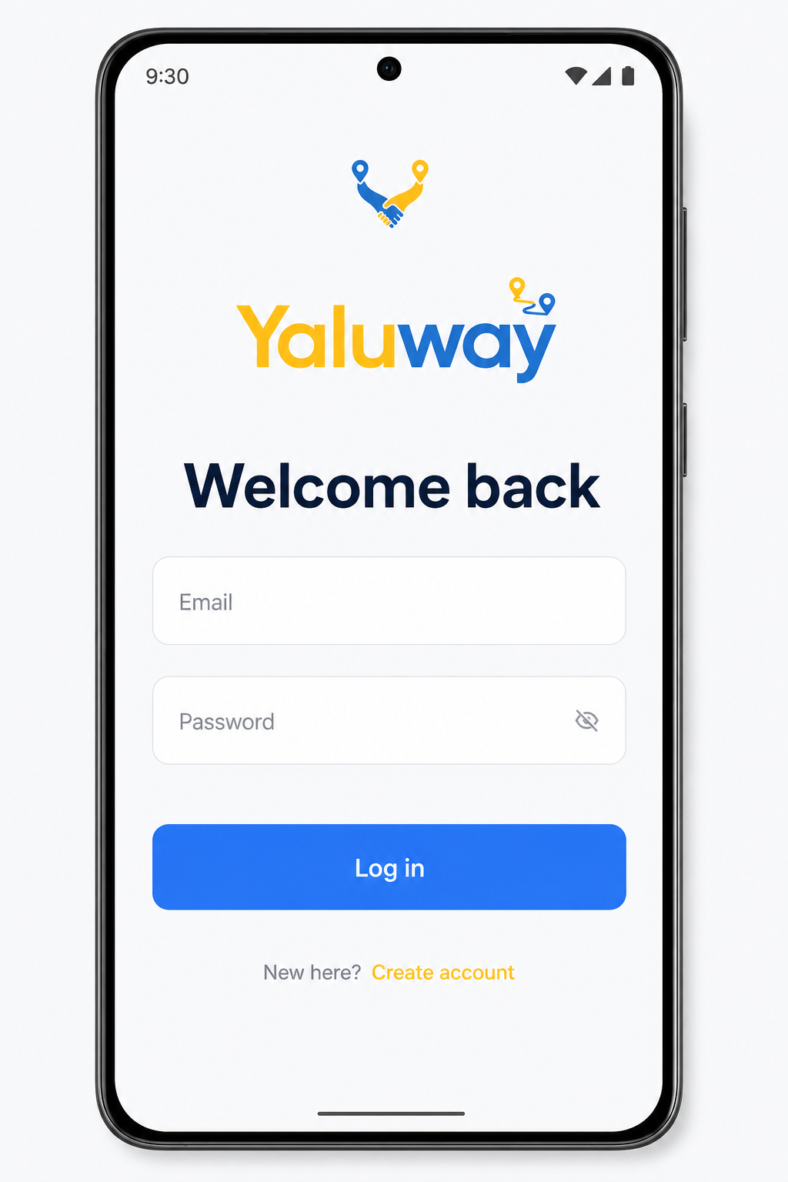

Figure 3. Splash (left) and Login (right).
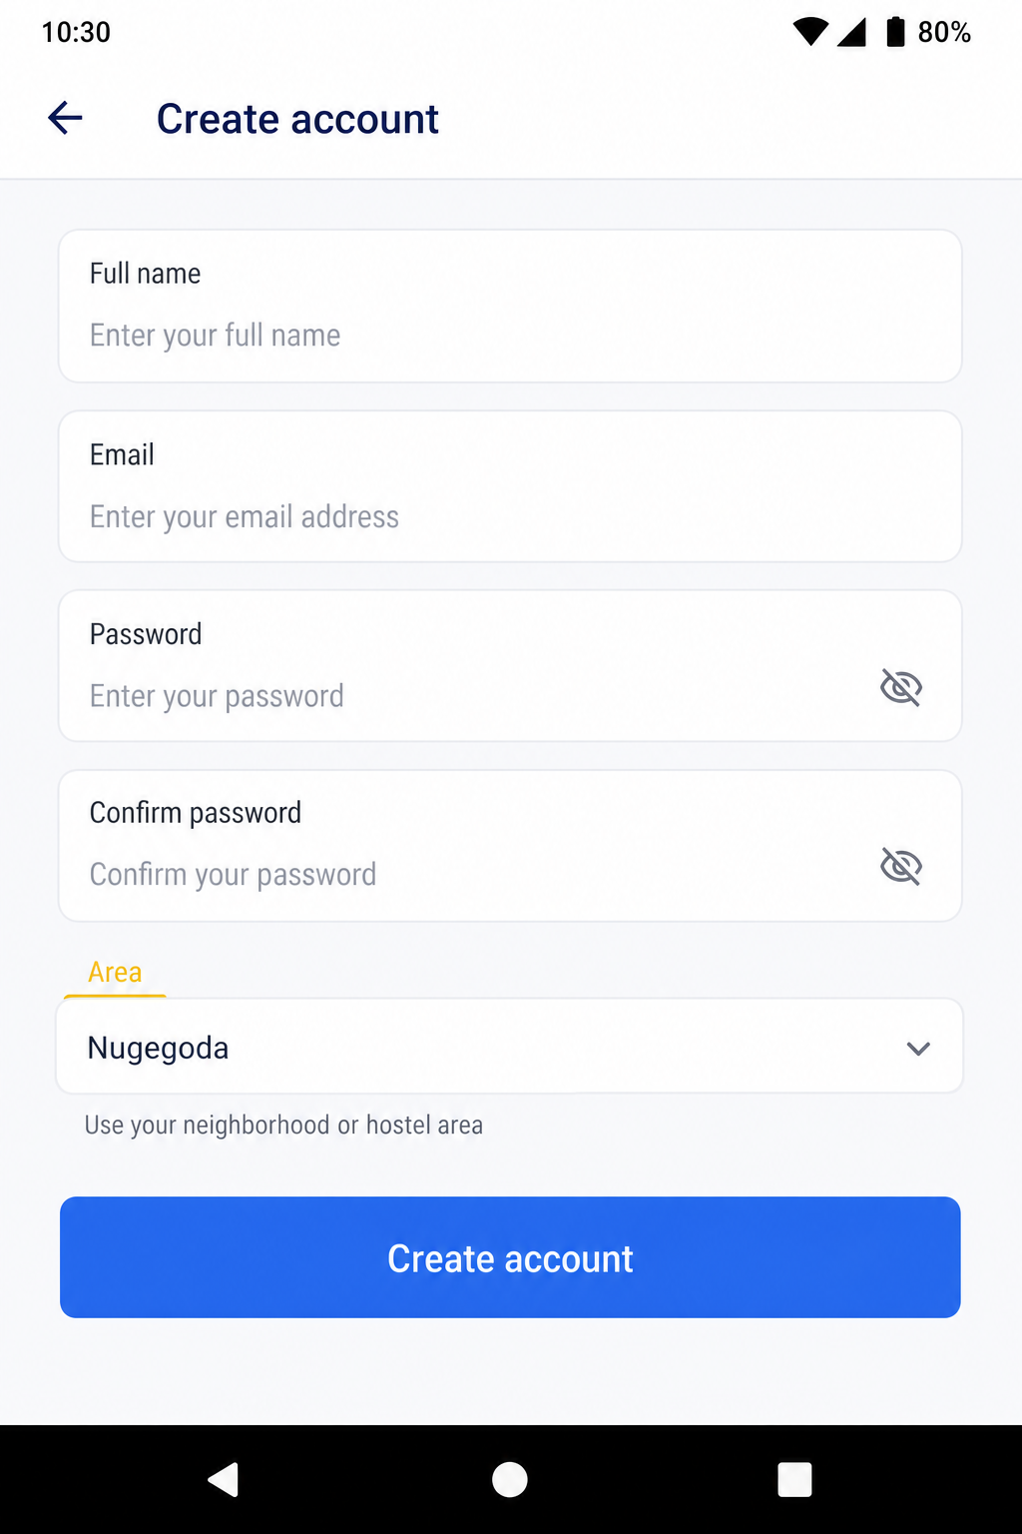
Figure 4. Register — Create account.
- Primary action is always a full-width blue button (30% colour).
- Create account on Login is yellow so it is visible without competing with Log in.
- No bottom navigation on these screens — the user is not inside the app yet.

5.2 Onboarding (Help, Services, Marketplace)
Three slides teach the 3-in-1 model before Home. Pagination dots show progress. Get started on the last slide enters the app. Illustrations use the same yellow-blue language as the logo so brand recognition starts before login content appears.
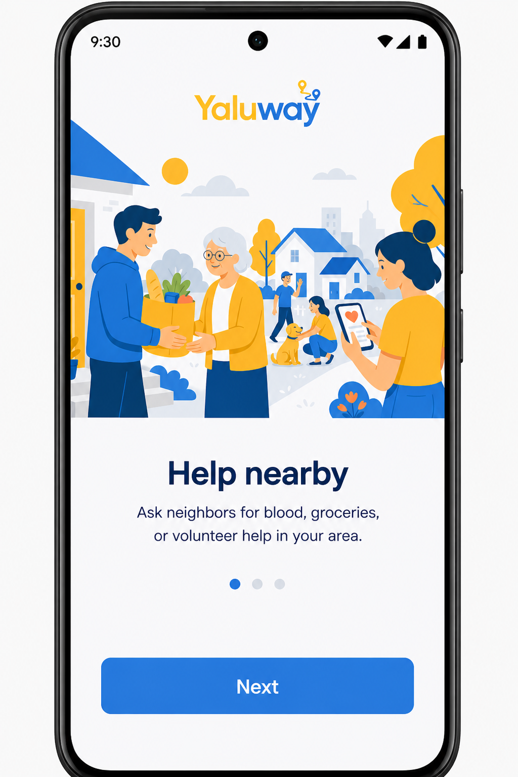 | 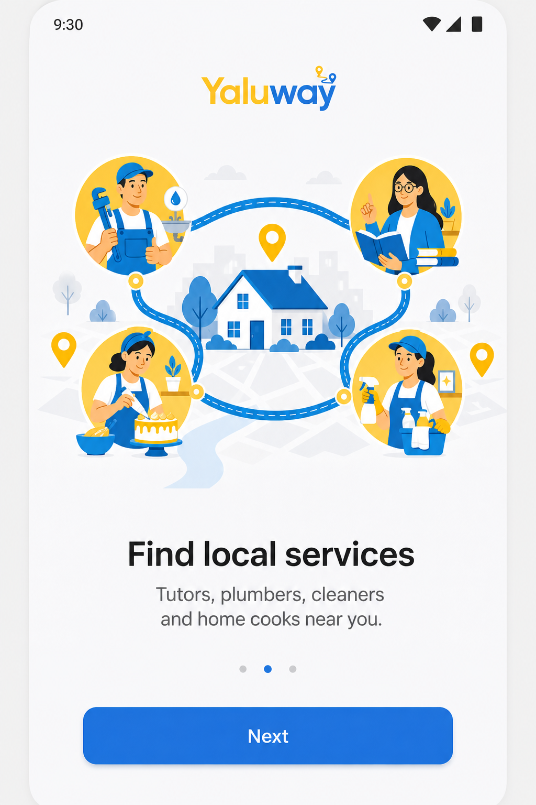

Figure 5. Onboarding 1 — Help nearby (left). Onboarding 2 — Find local services (right).
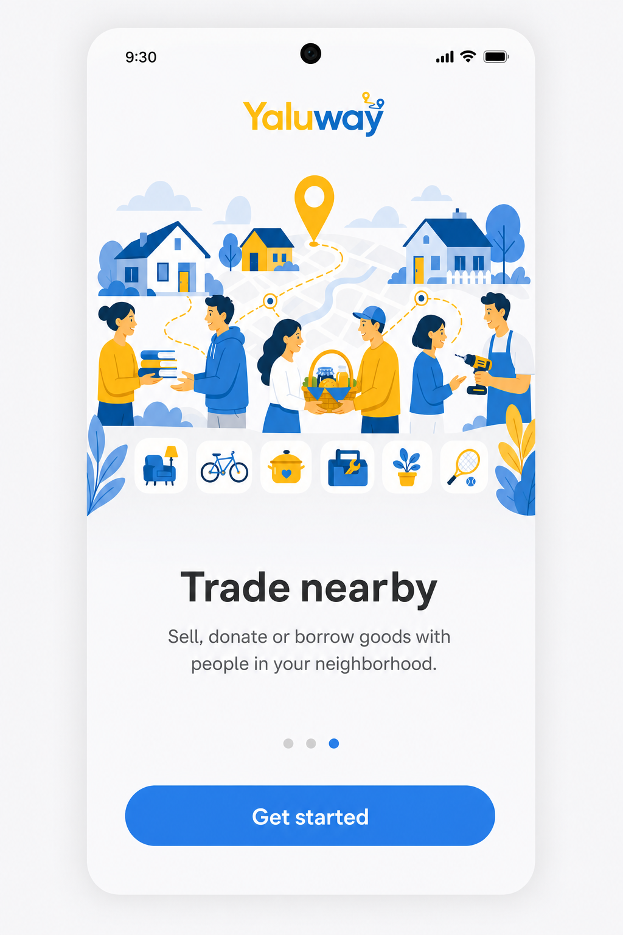
Figure 6. Onboarding 3 — Trade nearby, with Get started.

5.3 Home — main dashboard
Home is the main interface. It answers: where am I, what can I do, and what is nearby. Location (Nugegoda), search, three module chips, a mixed recent-posts feed, yellow FAB, and bottom navigation (Home | My posts | Me) are all on one screen.
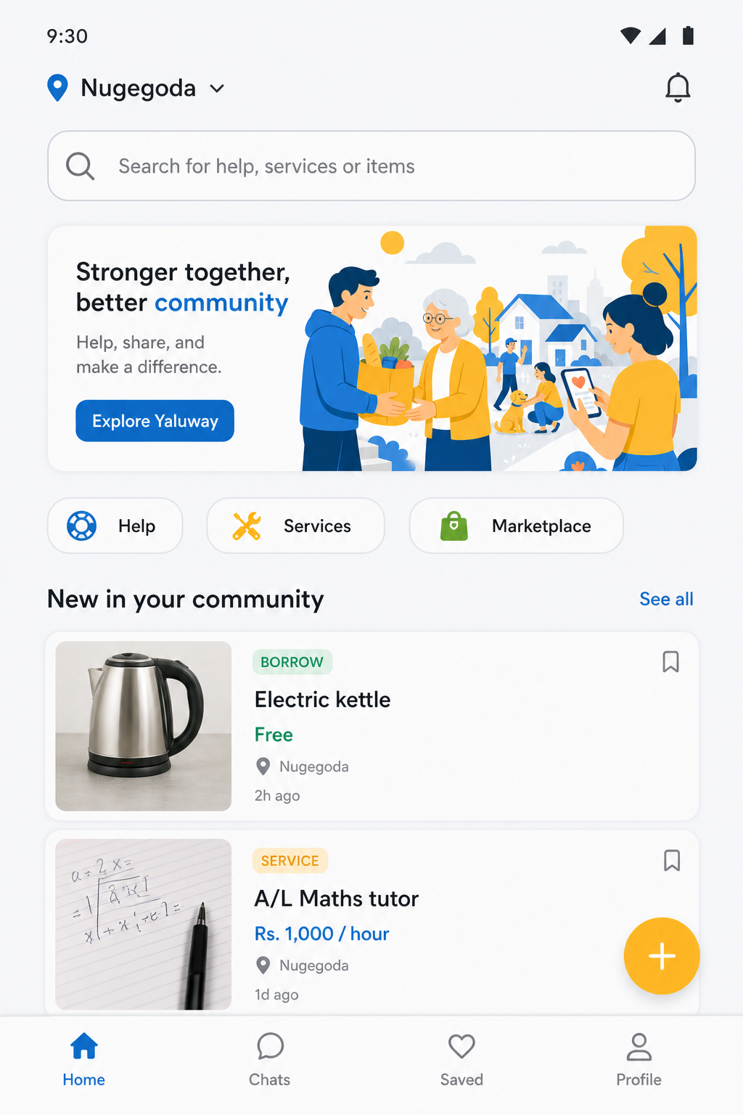
Figure 7. Home feed with Help / Services / Marketplace chips and yellow FAB.
- Chips filter the same list pattern — not three different apps.
- Card badges (HELP / SERVICE / BORROW) make post type scannable.
- FAB is yellow (10%) so “create” is always findable without a fifth nav item.

5.4 Help board
Help board is for urgent neighbourhood needs: blood requests, groceries for elders, volunteer tasks. A banner illustration sets the community-care tone. Filter chips (All, Urgent, Volunteer, Blood) reduce noise compared with a WhatsApp group.
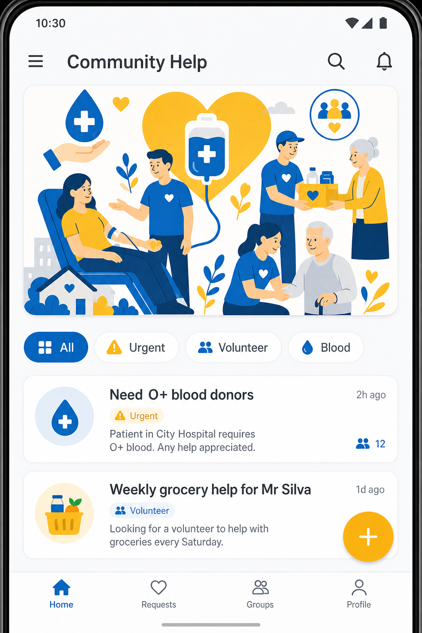
Figure 8. Community Help board.

5.5 Services directory
Services lists local skills: tutors, plumbers, cleaners, home cooks. Category cards with simple icons are faster than reading long classified ads. This screen covers the “community services” half of Topic 8 together with Help board.
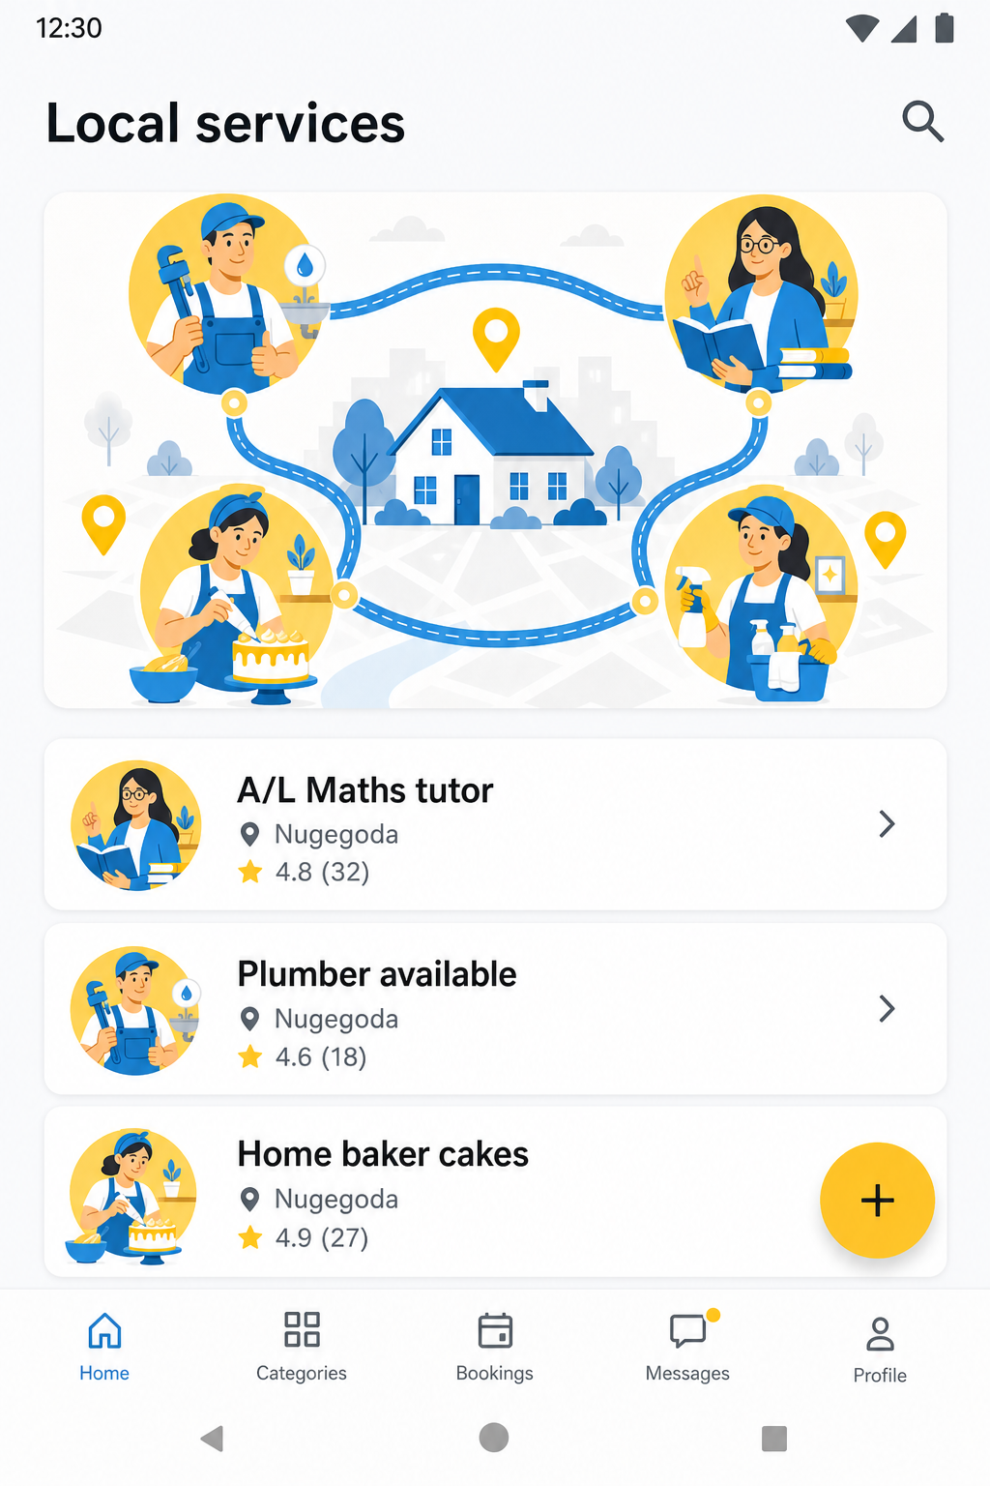
Figure 9. Local services directory.

5.6 Marketplace
Marketplace uses a two-column grid because users compare goods visually. Sell / Donate / Borrow chips are the key differentiator from ikman-style ads. Borrow selected in yellow shows the 10% accent used for a meaningful mode, not decoration.
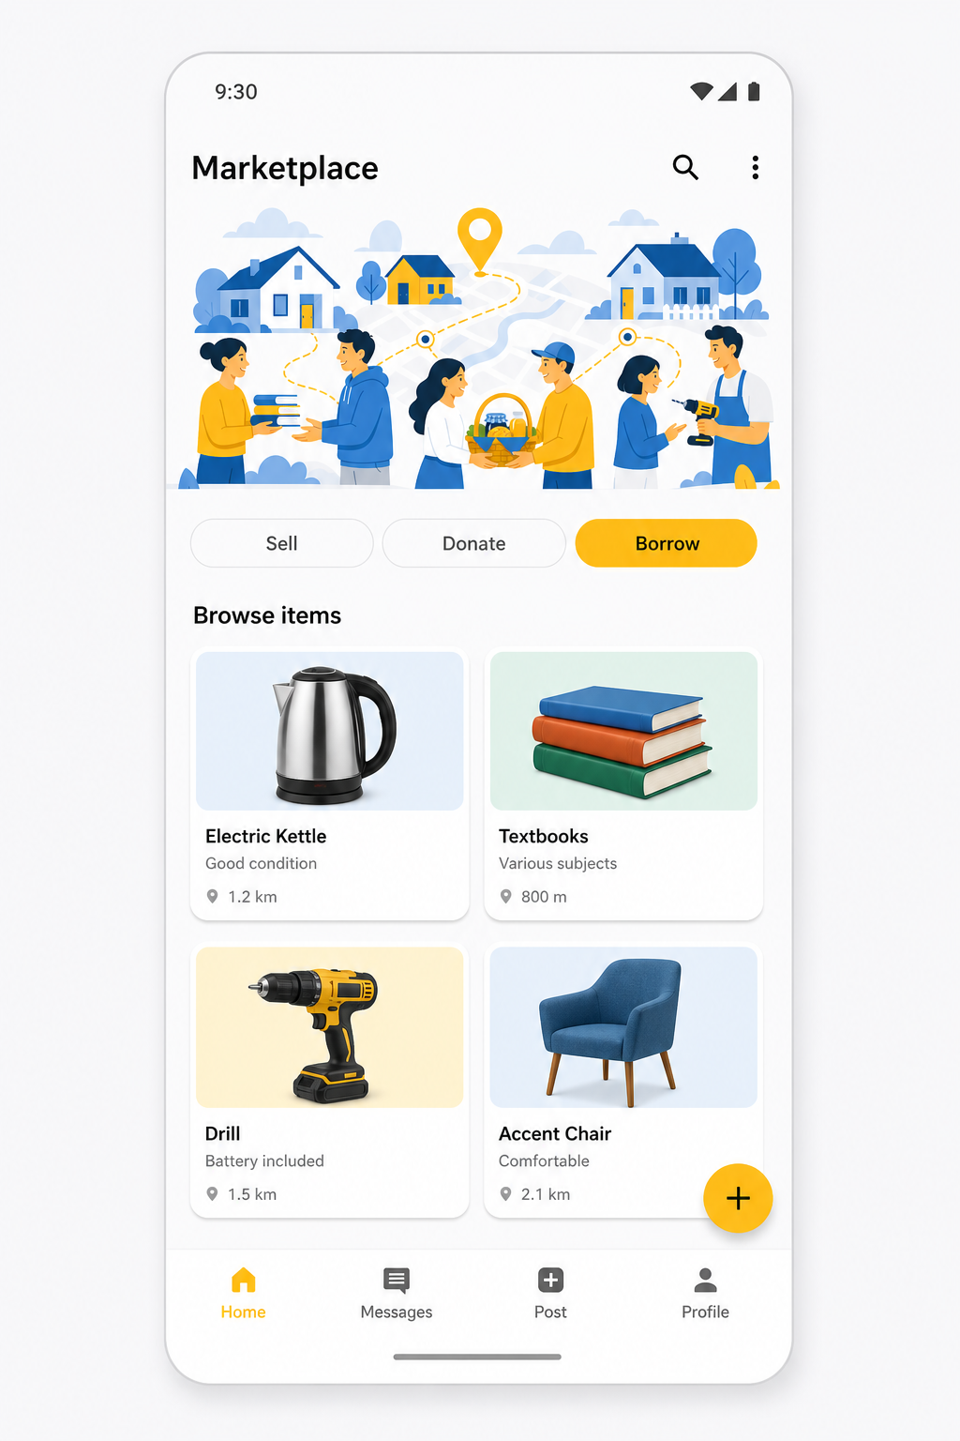
Figure 10. Marketplace grid with Sell / Donate / Borrow.

5.7 Post detail and Create post
Post detail shows one listing in full: hero image, type badge, title, area, poster, status, description, rating, Send request, and Save. Create post reuses one form for all three modules. Type (Help / Services / Marketplace) and Mode (Sell / Donate / Borrow) are chips, so the Kotlin app can store one Post table with type fields.
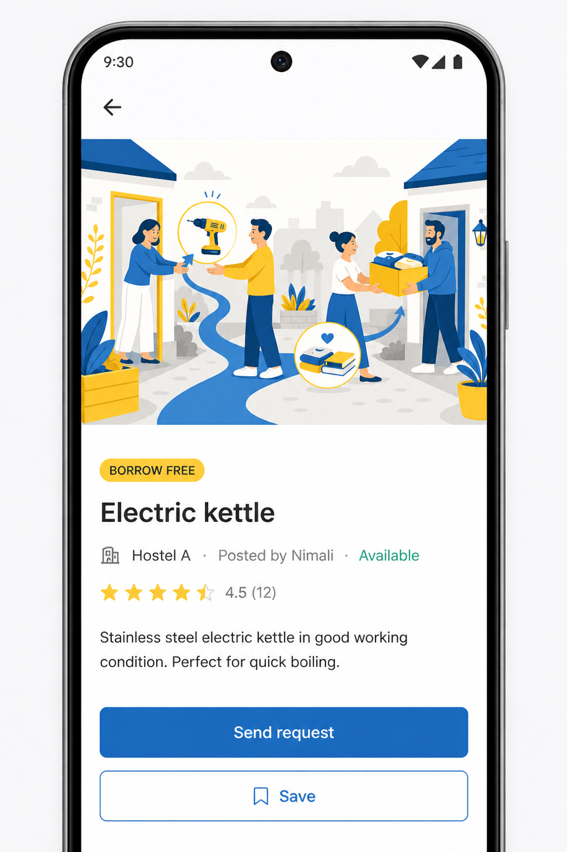 | 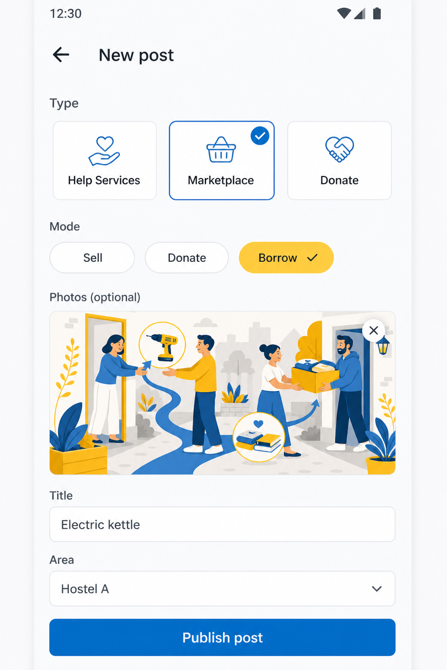

Figure 11. Post detail (left) and Create post (right).

5.8 Empty state, My posts and Profile
Empty state is shown when My posts has no data — important for first-time users and for usability marks. The filled My posts list shows the user’s own listings. Profile holds identity, area, trust score, stats (posts / saved / rating), and account actions including Logout.
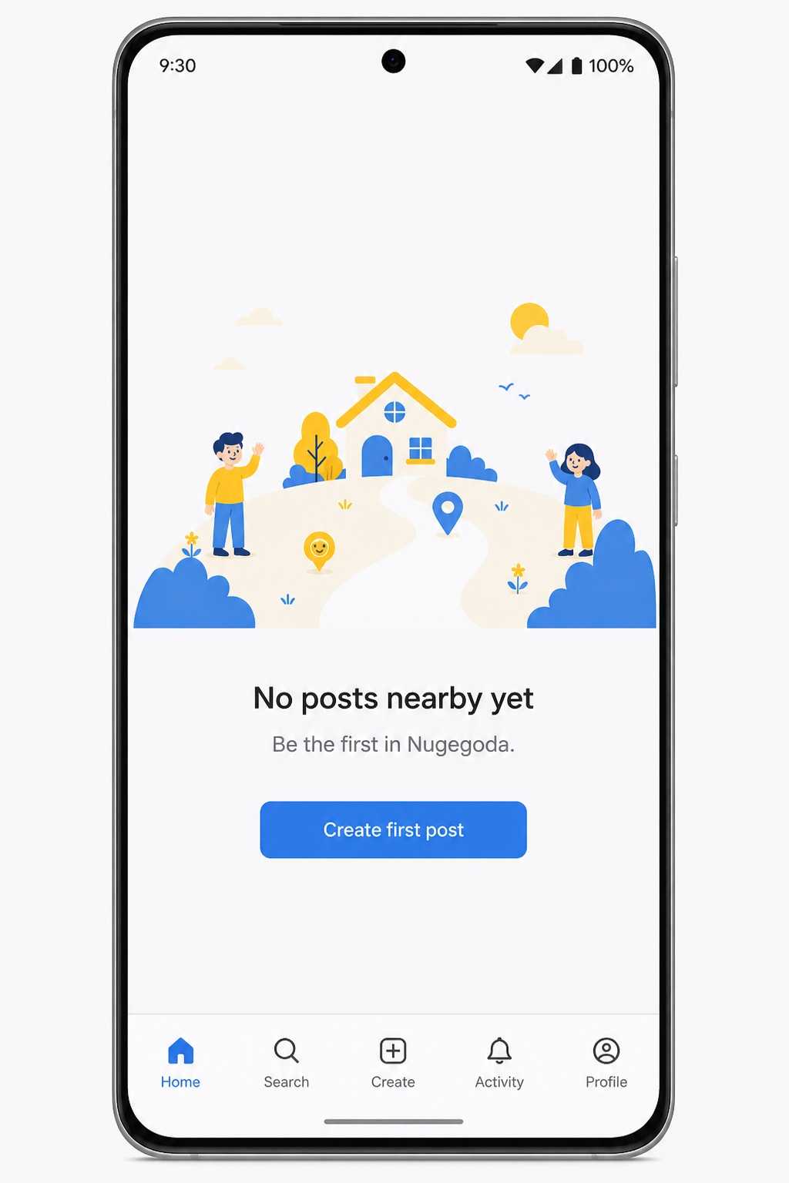 | 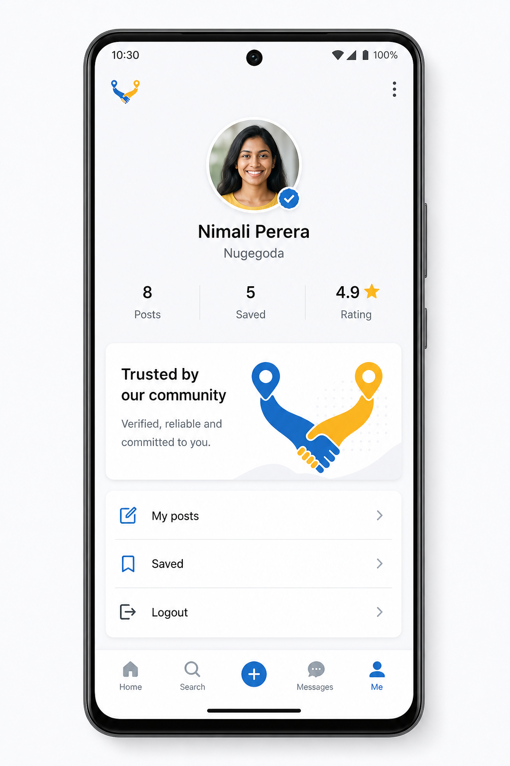

Figure 12. Empty state (left) and Profile (right).

6. Design Aesthetics and Usability

6.1 Visual aesthetics
- Flat Material-like UI: no heavy shadows, no gradients, no extra purple.
- Consistent 12 px rounded cards and 48 px primary buttons for a professional look.
- Illustrations share one style (blue + yellow neighbourhood scenes) so screens feel like one product.
- Typography hierarchy: large navy titles, smaller body, caption metadata in muted grey.
- Plenty of whitespace (60% background) so the UI does not feel crowded like social feeds.

6.2 Usability decisions
Principle | How the prototype applies it
Clarity | One primary button per screen; labels are verbs (Log in, Publish, Send request).
Consistency | Same header, FAB, and bottom nav pattern on all in-app screens.
Feedback | Selected chips change fill colour; empty state explains what to do next.
Error prevention | Register has Confirm password; Create post uses chips instead of free typing for type.
Learnability | Onboarding + Home chips teach the three modules in under a minute.
Accessibility | Navy text on off-white; large tap targets; high contrast blue buttons.
Efficiency | FAB is always available to create a post without opening a menu.
Local context | Area fields (Nugegoda, Hostel A) keep tasks neighbourhood-sized.

6.3 What was deliberately left out
Chat, payments, live maps, and AI matching are out of scope for the academic MVP. Hiding them from the prototype keeps the interface honest and matches the Kotlin + Room build plan. Users arrange pickup using profile contact outside the app.

7. Reusable Components (Design System)
A Design system page in Figma holds colour styles and components so screens stay consistent and later Android XML / Compose can map 1:1.
Component | Variants / use
Primary button | Filled #2F6FED, white text — Log in, Publish, Next
Outline button | Blue border — Save, secondary actions
Input field | Rounded, labelled — email, password, title, area
Chip | Unselected outline / selected fill — filters and modes
Post card | White card, badge, title, metadata
Bottom navigation | Home, My posts, Me with selected state
FAB | Yellow circle + — Create post

8. Interactive Prototype
Figma Prototype connections let the panel click through the app. Starting point is Splash.
From | Control | Goes to
Splash | Tap screen | Login
Login | Log in | Home
Login | Create account | Register
Register | Create account | Onboarding Help
Onboarding Help | Next | Onboarding Services
Onboarding Services | Next | Onboarding Marketplace
Onboarding Marketplace | Get started | Home
Home | Help / Services / Marketplace chips | Matching board
Home | Post card | Post detail
Any in-app screen | Yellow + FAB | Create post
Create post | Publish post | Home
Empty state | Create first post | Create post
Bottom nav | My posts / Me | My posts or Profile
Post detail | Back | Home

Play the prototype in Figma: open the file → Prototype tab → Play (present). Link: https://www.figma.com/design/0UVq1JYisRj6rl7UoadYFi/Untitled

9. Mapping to the Marking Scheme
Criterion | Max | Evidence in this prototype
Ideation | 3 | 3-in-1 hyperlocal Help + Services + Marketplace; brand යාළුway; Sri Lankan neighbourhood scenarios.
60-30-10 colour rule | 2 | Off-white 60 / blue 30 / yellow 10 applied on every screen; documented in Section 3.
Main interface design | 3 | 15 frames covering auth, onboarding, home, 3 boards, detail, create, empty, my posts, profile.
Aesthetics and usability | 2 | Consistent components, clear hierarchy, chips, FAB, empty state, contrast, no clutter.

10. Conclusion
The යාළුway Figma prototype is a complete, clickable UI for Topic 8. It turns a fragmented social-media problem into one neighbourhood notice board. Colour follows 60-30-10, screens share one component system, and the flow is ready to implement in Kotlin with Room. The next SDLC stage is development: the same screens become XML/Compose layouts, with posts stored locally and regular GitHub commits.

Appendix A — Screen inventory
# | Frame name | Purpose
1 | Splash | Brand entry
2 | Login | Returning user authentication
3 | Register | New account + area
4 | onboarding-help | Explain Help module
5 | onboarding-services | Explain Services module
6 | onboarding-marketplace | Explain Marketplace module
7 | Home | Dashboard / mixed feed
8 | help-board | Community requests
9 | Services | Local service categories
10 | Marketplace | Goods grid Sell/Donate/Borrow
11 | post-detail | Single listing
12 | create-post | Publish a listing
13 | empty-state | No posts yet
14 | my-posts | User’s own listings
15 | Profile | Account, trust, settings

Appendix B — Figma file
File name: Untitled (recommend renaming to Yaluway UI Prototype before submit).
URL: https://www.figma.com/design/0UVq1JYisRj6rl7UoadYFi/Untitled
Before uploading to Course Web: set the Figma file to “Anyone with the link can view”, paste the link in this report, export this document as PDF if the LMS requires PDF, and include your name and registration number on the cover (already filled).

